**CN Surprise Test-2**

**Name:** Sahil Kaundal **UID:** 21BCS8197

**Sem:** 4th **Section/Group:** 807/B

**Subject:** Computer Networks **Subject Code:** 20CST-256

**Q1. If the original data to send is 10011001 11100010 00100100 10000100. How would it be possible to detect error using two-dimensional error detecting technique?**

**Answer.**

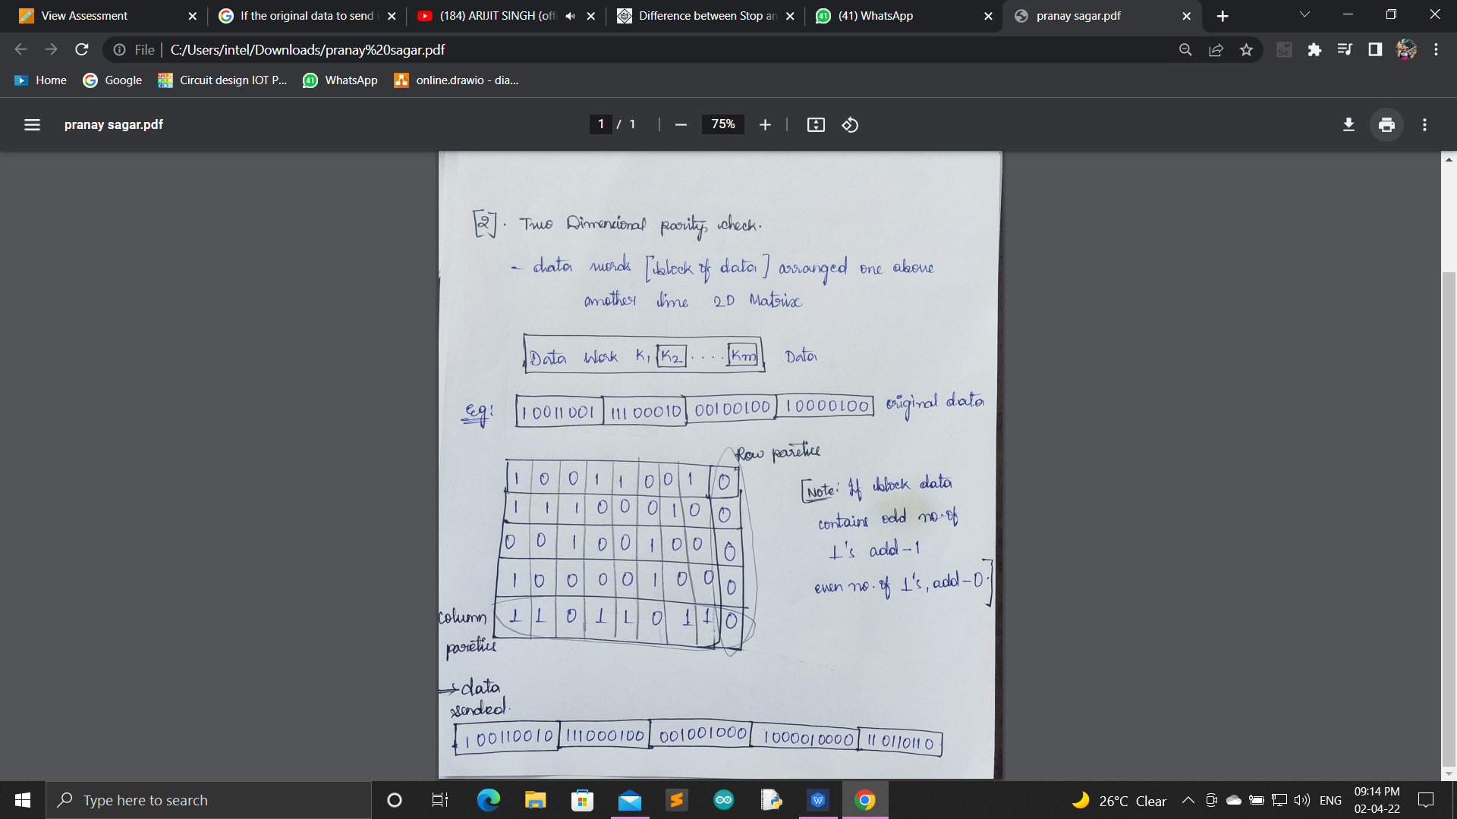

We will use checksum error detection technique

Consider the data unit to be transmitted is-

10011001111000100010010010000100

Consider 8 bit checksum is used.

**Step-01:**

At sender side,

The given data unit is divided into segments of 8 bits as-

**10011001 11100010 00100100 10000100**

Now, all the segments are added and the result is obtained as-

* 10011001 + 11100010 + 00100100 + 10000100 = 1000100011
* Since the result consists of 10 bits, so extra 2 bits are wrapped around.
* 00100011 + 10 = 00100101 (8 bits)
* Now, 1’s complement is taken which is 11011010.
* Thus, checksum value = 11011010

**Step-02:**

* The data along with the checksum value is transmitted to the receiver.

**Step-03:**

At receiver side,

* The received data unit is divided into segments of 8 bits.
* All the segments along with the checksum value are added.
* Sum of all segments + Checksum value = 00100101 + 11011010 = 11111111
* Complemented value = 00000000
* Since the result is 0, receiver assumes no error occurred in the data and therefore accepts it.

**Q2**. **Construct an example to explain the parity check method used for error detection.**

**Answer.**

**Error Detection Codes:**

The binary information is transferred from one location to another location through some communication medium. The external noise can change bits from 1 to 0 or 0 to 1.This changes in values are called errors. For efficient data transfer, there should be an error detection and correction codes. An error detection code is a binary code that detects digital errors during transmission. A famous error detection code is a Parity Bit method.

**Parity Bit Method:**

A parity bit is an extra bit included in binary message to make total number of 1’s either odd or even. Parity word denotes number of 1’s in a binary string. There are two parity system-even and odd. In even parity system 1 is appended to binary string it there is an odd number of 1’s in string otherwise 0 is appended to make total even number of 1’s.

There are two parity system-even and odd. In even parity system 1 is appended to binary string it there is an odd number of 1’s in string otherwise 0 is appended to make total even number of 1’s.

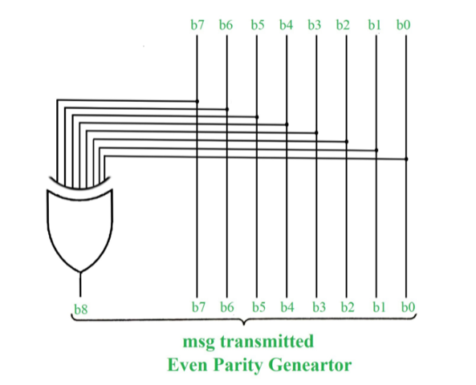

In odd parity system, 1 is appended to binary string if there is even a number of 1’s to make an odd number of 1’s. The receiver knows that whether sender is an odd parity generator or even parity generator. Suppose if sender is an odd parity generator, then there must be an odd number of 1’s in received binary string. If an error occurs to a single bit that is either bit is changed to 1 to 0 or O to 1, received binary bit will have an even number of 1’s which will indicate an error.

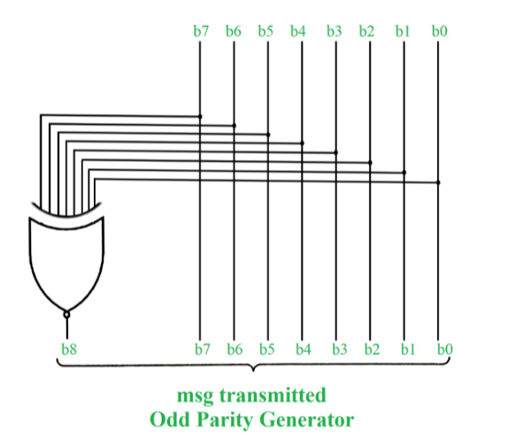

The limitation of this method is that only error in a single bit would be identified.

|  |  |  |
| --- | --- | --- |
| **Message (XYZ)** | **P(Odd)** | **P(Even)** |
| 000 | 1 | 0 |
| 001 | 0 | 1 |
| 010 | 0 | 1 |
| 011 | 1 | 0 |
| 100 | 0 | 1 |
| 101 | 1 | 0 |
| 110 | 1 | 0 |
| 111 | 0 | 1 |

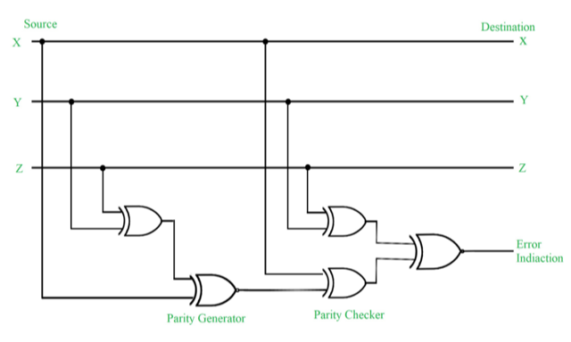

**Figure –** Error Detection with Odd Parity Bit

**Points to Remember:**

1. In 1’s complement of signed number +0 and -0 has two different representations.
2. The range of signed magnitude representation of an 8-bit number in which 1-bit is used as a signed bit as follows -27 to +27.
3. [Floating point number](https://www.geeksforgeeks.org/floating-point-representation-basics/) is said to be normalized if most significant digit of mantissa is one. For example, 6-bit binary number 001101 is normalized because of two leading 0’s.
4. [Booth algorithm](https://www.geeksforgeeks.org/computer-organization-booths-algorithm/) that uses two n bit numbers for multiplication gives results in 2n bits.
5. The booth algorithm uses 2’s complement representation of numbers and work for both positive and negative numbers.
6. If k-bits are used to represent exponent then bits number = (2k-1) and range of exponent = – (2k-1 -1) to (2k-1).

**Consider the data unit to be transmitted is 1001001 and even parity is used.**

Then,

**At Sender Side-**

* Total number of 1’s in the data unit is counted.
* Total number of 1’s in the data unit = 3.
* Clearly, even parity is used and total number of 1’s is odd.
* So, parity bit = 1 is added to the data unit to make total number of 1’s even.
* Then, the code word 10010011 is transmitted to the receiver.

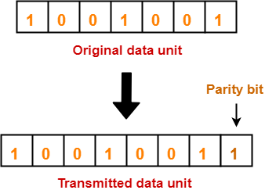

**At Receiver Side-**

* After receiving the code word, total number of 1’s in the code word is counted.
* Consider receiver receives the correct code word = 10010011.
* Even parity is used and total number of 1’s is even.
* So, receiver assumes that no error occurred in the data during the transmission.

**Q3. Differentiate between Error control and flow control mechanism.**

**Answer.**

**1.**[**Flow Control**](https://www.geeksforgeeks.org/flow-control-in-data-link-layer/)**:**   
It is an important function of the [**Data Link Layer**](https://www.geeksforgeeks.org/data-link-layer-in-osi-model/). It refers to a set of procedures that tells the sender how much data it can transmit before waiting for acknowledgement from the receiver.

**Purpose of Flow Control:**  
Any receiving device has a limited speed at which it can process incoming data and also a limited amount of memory to store incoming data. If the source is sending the data at a faster rate than the capacity of the receiver, there is a possibility of the receiver being swamped. The receiver will keep losing some of the frames simply because they are arriving too quickly and the buffer is also getting filled up.

This will generate waste frames on the network. Therefore, the receiving device must have some mechanism to inform the sender to send fewer frames or stop transmission temporarily. In this way, flow control will control the rate of frame transmission to a value that can be handled by the receiver.

**Example –** [**Stop & Wait Protocol**](https://www.geeksforgeeks.org/stop-and-wait-protocol-its-problems-and-solutions/)

**2.**[**Error Control**](https://www.geeksforgeeks.org/error-control-in-data-link-layer/)**:**   
The error control function of data link layer detects the errors in transmitted frames and re-transmit all the erroneous frames.

**Purpose of Error Control:**  
The function of the error control function of the data link layer helps in dealing with data frames that are damaged in transit, data frames lost in transit, and the acknowledgement frames that are lost in transmission. The method used for error control is called Automatic Repeat Request which is used for the noisy channel.

**Example –** [**Stop & Wait ARQ**](https://www.geeksforgeeks.org/stop-and-wait-arq/)**and**[**Sliding Window ARQ**](https://www.geeksforgeeks.org/sliding-window-protocol-set-1/)

|  |  |
| --- | --- |
| **Error Control Mechanism** | **Flow Control Mechanism** |
| Error control is meant for delivering the error-free data to the receiver. | Flow control is meant for the proper transmission of the data from sender to the receiver. |
| Parity checking, Cyclic Redundancy Code (CRC) and checksum are the approaches to detect the error in data. Hamming code, Binary Convolution codes, Reed-Solomon code, Low-Density Parity Check codes are the approaches to correct the error in data. | Feedback-based flow control and rate-based flow control are the approaches to achieve the proper flow control. |
| Detects and correct the error occurred in the data. | Avoid overrunning of receiver’s buffer and prevents the data loss. |
| Example of Error Control techniques are: Stop &Wait ARQ and Sliding Window ARQ. | Example of Flow Control techniques are: Stop &Wait Protocol and Sliding Window Protocol. |

**Q4. Elaborate sliding window flow control mechanism with example. Also differentiate it with stop and wait method.**

**Answer.**

Sliding window protocol is a flow control protocol. It allows the sender to send multiple frames before needing the acknowledgements. Sender slides its window on receiving the acknowledgement for the sent frames. This allows the sender to send more frames. It is called so because it involves sliding of sender’s window.

**Example:**

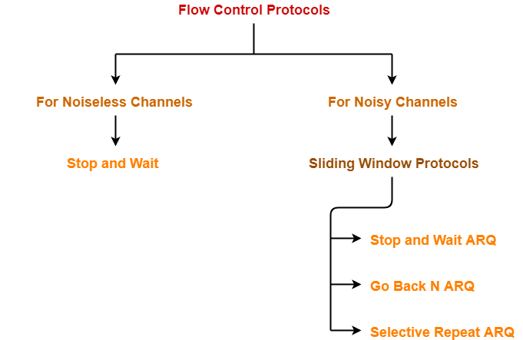

|  |  |  |  |
| --- | --- | --- | --- |
| **Sr. No.** | **Key** | **Stop and Wait Protocol** | **Sliding Window Protocol** |
| **1** | Mechanism | In Stop and Wait protocol, sender sends single frame and waits for acknowledgment from the receiver. | In Sliding window protocol, sender sends multiple frames at a time and re-transmits the damaged frames. |
| **2** | Efficiency | Stop and Wait protocol is less efficient. | Sliding Window protocol is more efficient than Stop and Wait protocol. |
| **3** | Window Size | Sender's window size in Stop and Wait protocol is 1. | Sender's window size in Sliding Window protocol varies from 1 to n. |
| **4** | Sorting | Sorting of frames is not needed. | Sorting of frames helps increasing the efficiency of the protocol. |
| **5** | Duplex | Stop and Wait protocol is half duplex in nature. | Sliding Window protocol is full duplex in nature. |

Sliding window protocols are data link layer protocols for reliable and sequential delivery of data frames. The sliding window is also used in Transmission Control Protocol.

In this protocol, multiple frames can be sent by a sender at a time before receiving an acknowledgment from the receiver. The term sliding window refers to the imaginary boxes to hold frames. Sliding window method is also known as windowing.

**Working Principle**

In these protocols, the sender has a buffer called the sending window and the receiver has buffer called the receiving window.

The size of the sending window determines the sequence number of the outbound frames. If the sequence number of the frames is an n-bit field, then the range of sequence numbers that can be assigned is 0 to 2𝑛−1. Consequently, the size of the sending window is 2𝑛−1. Thus in order to accommodate a sending window size of 2𝑛−1, a n-bit sequence number is chosen.

The sequence numbers are numbered as modulo-n. For example, if the sending window size is 4, then the sequence numbers will be 0, 1, 2, 3, 0, 1, 2, 3, 0, 1, and so on. The number of bits in the sequence number is 2 to generate the binary sequence 00, 01, 10, 11.

The size of the receiving window is the maximum number of frames that the receiver can accept at a time. It determines the maximum number of frames that the sender can send before receiving acknowledgment.

**Example**

Suppose that we have sender window and receiver window each of size 4. So the sequence numbering of both the windows will be 0,1,2,3,0,1,2 and so on. The following diagram shows the positions of the windows after sending the frames and receiving acknowledgments.

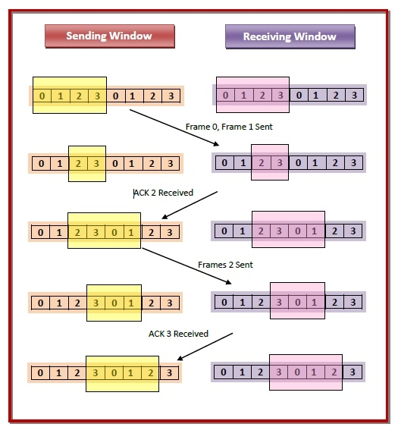

|  |  |
| --- | --- |
| **Stop and Wait protocol** | **Sliding Window protocol** |
| In Stop and Wait protocol, sender sends single frame and waits for acknowledgment from the receiver. | In Sliding window protocol, sender sends multiple frames at a time and retransmits the damaged frames. |
| Stop and Wait protocol is less efficient. | Sliding Window protocol is more efficient than Stop and Wait protocol. |
| Sender's window size in Stop and Wait protocol is 1. | Sender's window size in Sliding Window protocol varies from 1 to n. |
| Sorting of frames is not needed. | Sorting of frames helps increasing the efficiency of the protocol. |
| Stop and Wait protocol efficiency is formulated as 1/(1+2a) where a is ratio of propagation delay vs transmission delay. | Sliding Window protocol efficiency is formulated as N/(1+2a) where N is no. of window frames and a is ratio of propagation delay vs transmission delay. |
| Stop and Wait protocol is half duplex in nature. | Sliding Window protocol is full duplex in nature. |